Team ID_Team Name_CAD/CAE Report

Author’s Name:
Co-Author’s Name:

- Introduction
{First of all, read the instructions given at the end of this document carefully.
Under this section introduce the approach of starting your CAD Model. If any hand sketches were made, these can be provided at the end of report. If any prototype was made, then photographs must be incorporated. Introduce the software used for CAD & CAE work with their full name and versions. Please try to limit the introduction to 100 words.}
- Frame MAterial options
{List down the options of materials considered for the frame of your efficycle along with their properties. If same material is used with different cross-sections, then these should be written as separate combinations below.
Only those materials should be mentioned which are qualified as per the rulebook and have the availability in the market for your team.}
- Material-1 (Grade)
Cross-Section Type; A x B x t
- Material-2 (Grade)
Cross-Section Type; A x B x t
- ……..
- …….. (more can be added)
where;
A = Outer dia for circular section, Bigger side for Rectangular section, Major axis in case of elliptical section etc. (all dimensions in mm or inch)
B= Inner dia for circular section, Smaller side for Rectangular section, Minor axis in case of elliptical section etc. (all dimensions in mm on inch)
t= wall thickness in mm or inch.
[Comparison of material selection parameters should be shown in tabular format such as yield strength, ultimate strength, weight, cost, lead time for delivery etc.]
- calculation of bending strength and bending stiffness
{Show the full calculation of bending strength & bending stiffness of all material options and compare with the reference material given in the rulebook. The final results of all materials and reference material should be given in tabular format. Steps for calculations can be referred from the rulebook.}
- CAE ANalysis of Vehicle/Frame
{CAE Analysis on the frame should be performed to evaluate the safety offered by the frame to drivers in case of any accident including at least Frontal Impact, Side Impact and Rollover. If possible, the whole vehicle model can be subjected to this safety analysis through CAE. But as a minimum, analysis of frame is required in this report.
This CAE analysis shall be formed on all materials considered as frame material option as mentioned in Sr. No. 2 above.}
  - Frontal Impact Analysis
Material-1 (Write Name/Grade, Cross-section Size)
- Assumption & Considerations:
Mention all the assumptions considered for performing the analysis for frontal impact on frame/vehicle. All material conditions, structure simplification (such as omission of members), boundary conditions, meshing conditions impact conditions should be elaborated in detail.
- Calculation of Impact Forces:
The complete calculations for Impact Forces must be presented. Unit of Force shall be in Newton. The total impact forces and their distribution, if any must be presented with the help of FE Model. Teams may use snapshots taken from CAE tools for representation of FE model.
- Analysis Results:
{The analysis results such as deformation, stress, safety factor should be given here.
Include the images of results from CAE software}
- Optimizations:
Any optimizations performed on the vehicle/ frame should be listed down here.
Similarly, show the frontal impact analysis of vehicle/frame with other material options.
  - Side Impact Analysis
Material-1 (Write Name/Grade, Cross-section Size)
- Assumption & Considerations:
Same as given in 4.1.
- Calculation of Impact Forces:
Same as given in 4.1.
- Analysis Results:
Same as given in 4.1.
- Optimizations:
Same as given in 4.1..
Similarly, show the side impact analysis of vehicle/frame with other material options.
  - Rollover Analysis
Material-1 (Write Name/Grade, Cross-section Size)
- Assumption & Considerations:
Same as given in 4.1.
- Calculation of Impact Forces:
Same as given in 4.1.
- Analysis Results:
Same as given in 4.1.
- Optimizations:
Same as given in 4.1..
Similarly, show the rollover analysis of vehicle/frame with other material options.
  - Rear impact Analysis
Material-1 (Write Name/Grade, Cross-section Size)
- Assumption & Considerations:
Same as given in 4.1.
- Calculation of Impact Forces:
Same as given in 4.1.
- Analysis Results:
Same as given in 4.1.

- Optimizations:
Same as given in 4.1..
Similarly, show the rear imapct analysis of vehicle/frame with other material options.
Any other analysis such as torsional loading etc may be included, if performed by team.
- final MATerial selection
{Different materials must be compared on the basis of CAE results and other parameters such as manufacturability, weight of vehicle then represent in tabular format.}
Materials Selected for Frame:
- Material 1 Grade, Cross-Section Type, Size
- Material 2 Grade, Cross-Section Type, Size
- ……………….(List down all selected materials)
- CAE ANalysis of other parts
CAE analysis of all such parts must be performed which are critical for vehicle operation. Generally customized parts or in-house fabricated parts should be included here (e.g. wheel hub, suspension arms, seatback support member, fairing supports etc.). The analysis of these parts should be presented with the help of sub-headings as given in section 4.1 above.
CAD Models of all these parts should be shown with the dimensions at Appendix-1.}
- Vehicle Views
Vehicle views should be included at the Appendix-1 with all dimensions as asked (all views given at Appendix-1 are mandatory). Complete CAD model with the placement of all components should be shown.
If required more pictures of the CAD model may be inserted at Appendix-1 (e.g. Both side views if the sitting height for both drivers is different in case of adjacent seats, detailed view of subsystems etc.). All the pictures must be full page pictures at Appendix-1 and can be rotated for better presentation.
If the space of CAE images is felt insufficient in the document, these may be placed as Appendix-2 at the end of report with proper captions and picture numbers. The picture numbers should be referred in the main document content.
All hand sketches, 2D drawings, prototype images may be included in Appendix-2.

APPENDIX-1 : Vehicle Views

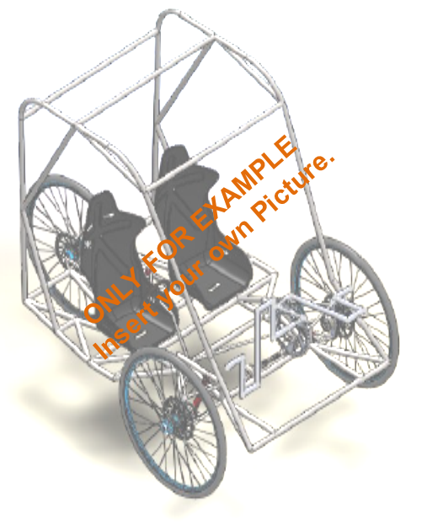

Figure-1 (Isometric View of Vehicle)

APPENDIX-1 : Vehicle Views (contd..)

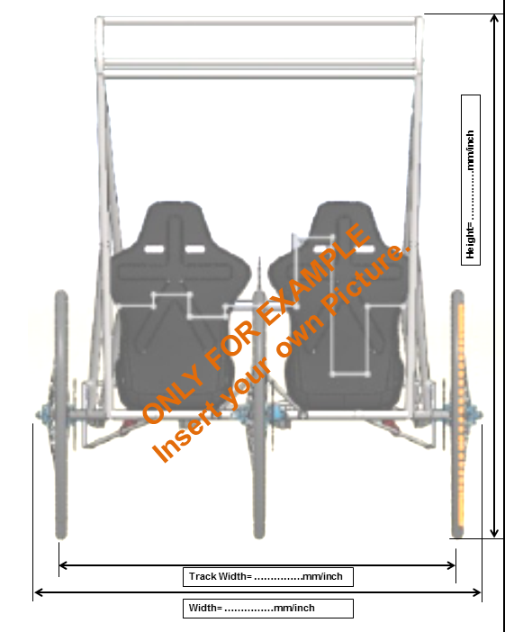

Figure-2 (Front View of Vehicle)

APPENDIX-1 : Vehicle Views (contd..)

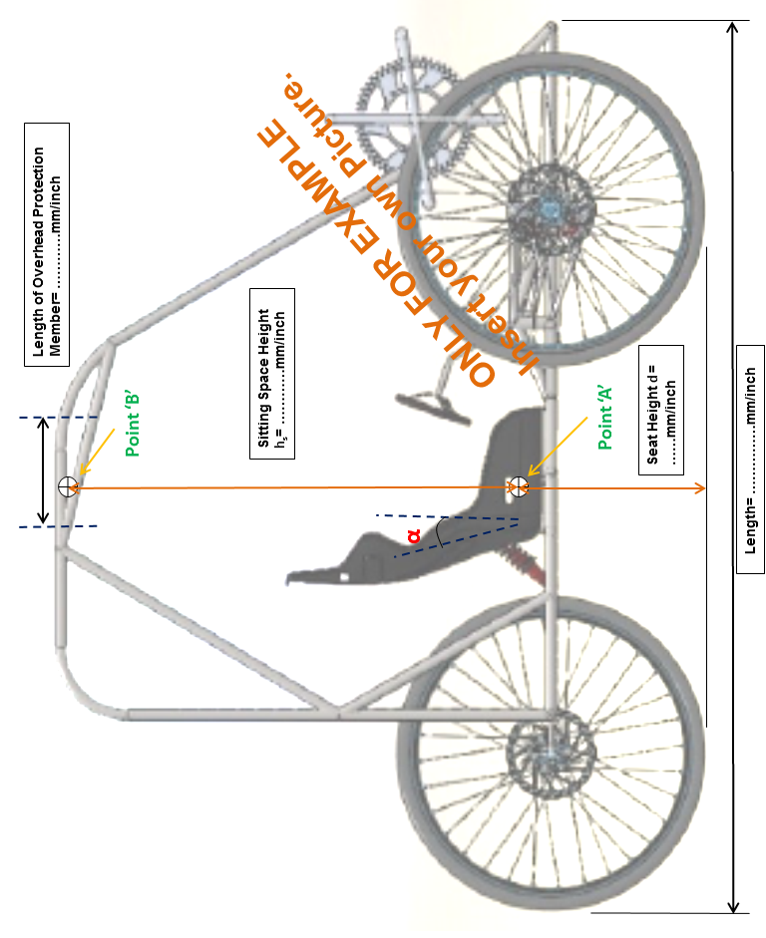

Figure-3 (Side View of Vehicle)

APPENDIX-1 : Vehicle Views (contd..)
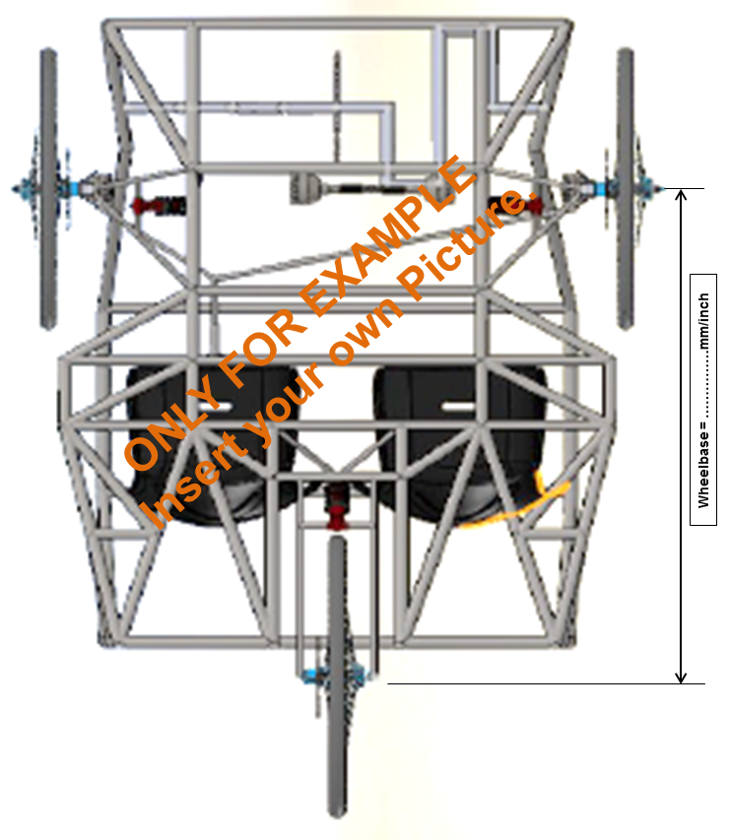

Figure-4 (Top View of Vehicle)
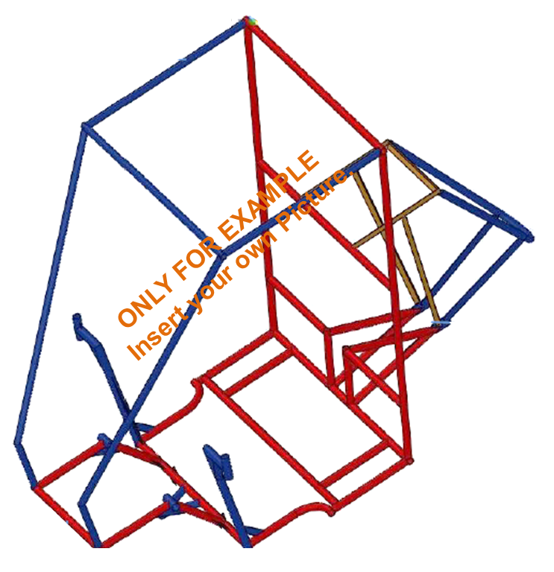
APPENDIX-1 : Vehicle Views (contd..)

{Different Materials/Cross-section should be shown with different colors.}

Figure-5 (CAD Model of Frame)

Guidelines
- The CAD model must be complete for the presentation in CAD/CAE Report.
- The document must be prepared in this template only. Change in format (header/footer/sequence) will not be accepted. Any heading cannot be omitted.
- Document size should not exceed 5MB, whereas number of pages is not restricted.
- This format is a 97-9003 word template. Document must be saved as Team ID_Team Name_CAD Report as a separate ‘.pdf’ file.
- The file must be submitted as a part of documentation package as per the guidelines documents which will be released later.
- The font must be “Helvetica”, black, 10 size.
How to use Report template
- Open the report template. File extension is .dot.
- Save it as word document with document name Team ID_Team Name_CAD Report (write your team ID and Team name here)
- Now check the file extension. It should be .doc or .docx.
- Check that the document has the header and footer same as given in the template.
- Start writing your content in the new document created by you.
- After the completion of document, check the format of such as header, footer, 2 columns format, pictures placement etc.
- Now save as .pdf file and then submit as mentioned in guidelines which will be released later.

